**Request for Proposals, 9/23/2024**

**Memorial Regional Health**

**Emergency Medical Services Station and Training Facility**

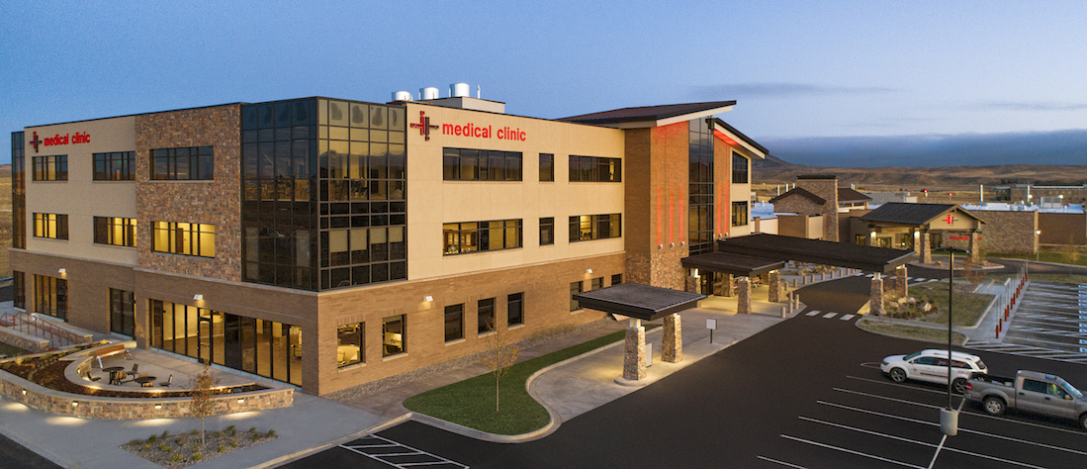

**Workforce and Economic Development**

**Feasibility Study**

**Submission Deadline: 10/11/2024**

**TABLE OF CONTENTS**

**SECTION I: Issuing Office, Description, and Timeline**

**SECTION II: Administrative Information**

**SECTION III: Overview and Goals**

**SECTION IV: Requirements and Statement of Work**

**SECTION V: Evaluation and Award**

**EXHIBITS:**

**A. Request for Proposals Signature Page (RETURN)**

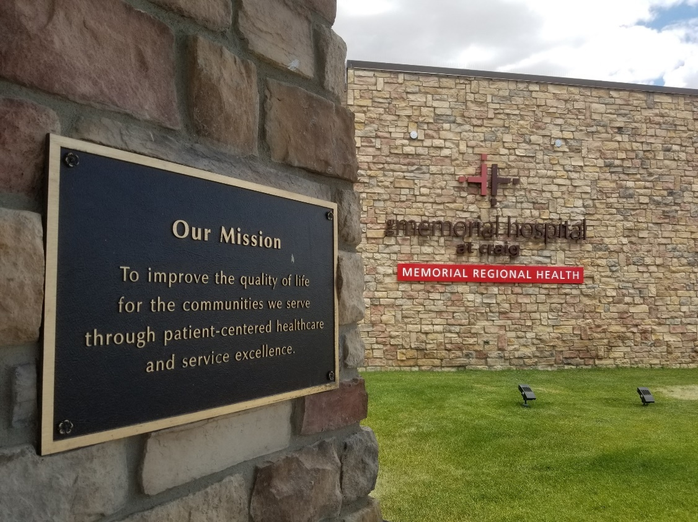

**SECTION I**

**ISSUING OFFICE, DESCRIPTION, AND TIMELINE INFORMATION**

**A. ISSUING OFFICE:**

Memorial Regional Health (MRH) is issuing this request for proposals (RFP) through grant funding from the Moffat County Local Marketing District (MCLMD). Any individual or organization with an interest may submit a proposal in accordance with the terms of this RFP.

**B. MEANS OF COMMUNICATION:**

If we must revise any part of this RFP, we will notify all entities that have expressed interest in submitting a proposal. MRH is the sole point of contact for this RFP.

**C. PURPOSE:**

The purpose of this RFP is to solicit proposals for a contractor who will assist MRH in completing a workforce and economic development feasibility study on the emergency medical services (EMS) station and training facility we are planning to construct over the next two years. The successful applicant must have experience overseeing grant projects.

**D. SCOPE:**

This RFP contains instructions for proposals and all materials applicants must include therein, mandatory requirements applicants must meet to be eligible, and other requirements.

**E. STAFF:**

Proposals should include resumes or biographical summaries of all personnel who will be participating on the project.

**F. BUDGET:**

Proposals must include a detailed budget that outlines personnel services (e.g., number of staff contributing to the project, job titles, description of work, and anticipated number of hours assigned to the project), supplies/operating expenses, and travel expenses (e.g., mileage, lodging, and meals per diem).

**G. LETTERS OF REFERENCE:**

Applicants may submit up to three letters of reference, but they are not required.

**H. SCHEDULE OF ACTIVITIES:**

|  |  |  |
| --- | --- | --- |
| **ACTIVITY** | **TIME** | **DATE** |
| 1. MRH releases RFP | 8 a.m. (Mountain) | 9/23/2024 |
| 2. RFP clarification questions due to MRH | 5 p.m. | 9/30/2024 |
| 3. MRH responds to all clarification questions | 5 p.m. | 10/4/2024 |
| 4. RFP submission deadline | 5 p.m. | 10/11/2024 |
| 5. MRH to review response packages and select contractor | 5 p.m. | 10/18/2024 |
| 6. MRH and successful applicant to finalize contract | 5 p.m. | 10/31/2024 |

**I. TERM OF CONTRACT:**

We anticipate that the term of this resulting contract is will be 11/1/2024 to 4/30/2025.

**SECTION II**

**ADMINISTRATIVE INFORMATION**

**A. OFFICIAL MEANS OF COMMUNICATION:**

During the solicitation process for this RFP, all official communication from MRH shall be through written notices via email. Notices may include any modifications to administrative or performance requirements, answers to inquiries, clarifications to requirements, and our announcement of the successful applicant.

**B. INQUIRIES:**

Unless otherwise noted, prospective applicants may make e-mail inquiries concerning this RFP to obtain clarification of requirements. We will not accept inquiries after the date and time we indicated in the RFP Schedule of Activities. We will email responses to applicants’ inquiries as we indicated in the RFP Schedule of Activities.

* E-mail all inquiries to: [ryan.lucas@memorialrh.org](mailto:ryan.lucas@memorialrh.org).
* Clearly identify your inquiries as ***MRH EMS Station and Training Facility*** in the email subject line.

**C. MODIFICATION OR WITHDRAWAL OF PROPOSALS:**

Respondents may modify or withdraw proposals at any time prior to the final submission deadline.

**D. PROPOSAL SUBMISSION:**

MRH must receive all proposals via email on or prior to the date and time we indicated in the RFP Schedule of Activities. Applicants are responsible for ensuring that MRH has received their proposal on or prior to the deadline. We will not accept late proposals. Applicants must sign the RFP Signature Page.

Applicants must send proposals via email to: [ryan.lucas@memorialrh.org](mailto:ryan.lucas@memorialrh.org).

**E. PROPOSAL NARRATIVE LENGTH AND PAGE FORMATTING:** Applicants must adhere to the following length and page formatting instructions:

**Total Proposal Length:** Maximum of five (5) pages (resumes, budget, references, and other attachments are not included in this count)

**Font:** Twelve (12) point

**Spacing:** Single

**Margins:** One (1) inch margins on all sides

**Paper:**  8½ x 11

**Footer:**  Page number

**Acronyms** Define all acronyms in the proposal.

**Attachments:** - Resumes of all staff who will contribute to the project

* Project Budget
* Up to three (3) letters of reference (not included in total proposal length)
* RFP Signature Page

**F. ACCEPTANCE OF RFP TERMS:**

Applicant proposals signify that they acknowledge all terms and conditions of this invitation for an offer. An applicant shall identify clearly and thoroughly any variations between their proposal and MRH’s RFP. Failure to do so shall be deemed a waiver of any rights to subsequently modify the terms of performance, except as the RFP specifies.

**G. PROTESTED SOLICITATIONS AND AWARDS:**

Any applicant who is aggrieved in connection with the solicitation or award of a contract may protest to MRH. The applicant must submit this protest in writing within seven (7) working days after such aggrieved applicant knows, or should have known, of the facts giving rise thereto.

**H. EVALUATION:**

See Section V for Evaluation information.

**I. PROPOSAL SELECTION:**

See Section V for Proposal Selection information.

**J. PROPOSAL ACCEPTANCE:**

See Section V for Proposal Acceptance information.

**K. STANDARD CONTRACT:**

If the successful applicant will be completing this project as a representative of a business entity, that entity must be registered to do business in the State of Colorado. This registration is maintained through the Colorado Secretary of State Office (<http://www.sos.state.co.us/>). If the applicant is a representative of a foreign corporation (formed under a statute or common law in a jurisdiction other than Colorado) or other foreign entity transacting business in the State of Colorado, that corporation shall warrant that they have obtained and shall maintain any applicable certificate of authority to transact business in the State of Colorado and have designated a registered agent in Colorado to accept service of process.

**L. RFP CANCELLATION:**

MRH reserves the right to cancel this RFP at any time, without penalty.

**M. MRH OWNERSHIP OF CONTRACT PRODUCTS/SERVICES:**

All proposals become the property of MRH. All products/services we produce in response to the contract resulting from this RFP will be the sole property of MRH, unless the RFP notes otherwise. MRH has the right to retain the original proposal and other RFP response materials for our files.

**N. INCURRING COSTS:**

MRH is not liable for any applicant cost prior to issuance of a legally executed contract or procurement document.

**O. PROPOSAL REJECTION:**

MRH reserves the right to reject any or all proposals, to waive informalities and minor irregularities in proposals, and to accept any or all portions of a proposal if we deem them in the best interest of MRH.

**P. VENDOR IDENTIFICATION:**

If the successful applicant will be completing this project as a representative of a business entity, the tax identification number must be that of the applicant’s business responding to the RFP. The applicant must be a legal entity with the legal right to contract.

**Q. NEWS RELEASES:**

News releases pertaining to this RFP shall NOT be made prior to contract execution without prior written approval from MRH.

**R. CERTIFICATION:**

Each person signing the RFP Signature Page of this proposal certifies that they are responsible as to the services being offered herein.

**S. CONFLICTS OF INTEREST:**

The holding of public office or employment is a public trust. A public officer or employee whose conduct departs from his fiduciary duty is liable to the people of the State. Rules of conduct for public officers and state employees apply to this RFP.

**T. PUBLIC CONTRACTS FOR SERVICES:**

Effective May 13, 2008, contractors who enter into or renew a public contract for services with Colorado state agencies or political subdivisions must participate in either the Federal E-Verify program or the Colorado Department of Labor and Employment Program. For more information, see: E-Verify Program (<http://www.dhs.gov/e-verify>); or Colorado Department of Labor and Employment Program and notice forms, Colorado Division of Labor (<https://www.colorado.gov/cdle>).

**U. CONTRACT NONCOMPLIANCE:**

Contractor’s failure to fulfill all obligations and notify MRH in a timely manner may result in the delay of payment of funds and/or contract termination.

**V. SUBCONTRACTS:**

Contractors shall submit to MRH copies of any and all subcontracts the they secure to perform their obligations hereunder. Any and all subcontracts the contractor enters shall comply with all applicable federal and state laws and shall provide that the laws of the State of Colorado will govern such subcontracts.

**SECTION III**

**OVERVIEW AND GOALS**

MRH is a rural county entity with a 25-bed Critical Access Hospital (CAH), multi-specialty medical clinic (Rural Health Clinic), and other clinics located in and caring for the residents of Northwest Colorado. A healthcare mainstay in an isolated region, MRH operates for a medically underserved population in a Primary Care Geographic Health Professional Shortage Area (HPSA). We have served Moffat County and the surrounding area since 1949, and we now have almost 400 staff members, making us one of the largest employers in our part of the state. MRH’s mission is to improve the quality of life for the communities we serve through patient-centered healthcare and service excellence.

We are uniquely positioned as the sole EMS provider in the City of Craig and for much of Moffat County, Colorado’s second-largest county and a geographic area that almost equals the size of Connecticut. MRH also operates the only advanced cardiac life support (ACLS) EMS team in Northwest Colorado. Overall, we serve more than 2,700 square miles of Moffat County’s vast space, providing ambulance service 24 hours a day, 365 days per year at an average of 1,800 annual calls. We additionally make regular interfacility transports to Denver and Grand Junction with critical patients. With a high local Medicaid population mix and low reimbursement rates for most services, this essential service line saves many lives at an approximately $750,000 loss for MRH each year.

Moving forward with this vital service, our goal is to construct a new EMS station and training facility over the next two years. This project will provide multiple benefits, including: Recruiting and retaining MRH EMS personnel, as it will create formal sleeping/resting quarters to replace the makeshift ones we have onsite right now; housing all our ambulances together next to our hospital and medical office building, as we currently lease a small ambulance bay offsite for part of our fleet; becoming a regional hub for EMS training with first responder agencies across Northwest Colorado, including revitalization of the local emergency medical technician (EMT) training program through Colorado Northwestern Community College (CNCC); and providing viable career paths for interested employees currently at area coal-fired power plants and mines scheduled to close over the next half-decade, with the whole region now bracing for a major identity shift and actively seeking ways to transition this robust workforce and retain a large part of our tax base.

MRH is early in construction planning, having consulted with an architecture firm for building designs. We are also communicating with multiple government and private foundation funding sources for infrastructure grants, and we aim to complete a capital stack that allows us to construct the facility without adding new debt. While we have not yet applied for any of these opportunities, government and foundation funders see the value in this project, agreeing to work with us in ensuring we submit successful grant applications.

We have also secured support from a number of partners that operate throughout Northwest Colorado. These agencies provide us with backing from a wide range of specialties, including: Local government agencies; the regional career transition navigator at the Office of Just Transition, a state program assisting communities as they move away from their extractive industry histories; the Northwest Colorado Development Council (NWCDC), an intergovernmental agreement (IGA) between the three counties and their municipalities across our region to collaborate on area economic and community development; partners in local education, including CNCC; partners in business and economic development; and others.

Our EMS manager and current staff with experience in running a training center are also collaborating with the state on the requirements to launch that part of our facility. This process will include several integral steps: Obtaining and maintaining state authorization on EMS training center certification; updating internal policies and procedures; investigating software upgrades for collecting data that we can differentiate from standard EMS calls; adding insurance coverage for onsite training; updating curricula, with several MRH EMS and nursing employees already currently working as trainers; and exploring which trainings to offer, possibly including EMT, advanced emergency medical technician (AEMT), advanced cardiac life support (ACLS), pediatric advanced life support (PALS), basic life support (BLS), trauma nursing core course (TNCC), emergency nursing pediatric course (ENPC), Stop the Bleed, continuing education for paramedics, refresher courses for critical care paramedics and critical care nurses, and others.

Finally, in revitalizing the former local EMT training program, CNCC is open to having MRH serve as the training site. CNCC will be able to list these trainings as non-credit courses for students, with the classes still counting toward associate degree programs. The local college also has an array of equipment and other resources MRH can borrow for the training facility. Additionally, regional partners in education and youth development such as Yampa Valley Partnership for Students, Stewardship, and Sustainability (YVPS3) can help us amplify the effect of our local mini-med school program, which currently does local outreach in showing the importance of healthcare careers to youth populations.

MRH does not have quantitative details yet on the total jobs and economic benefits this EMS station and training facility project will produce for the region. We already currently offer trainings to local first responder agencies such as Craig Fire and Moffat County Emergency Response, but we want to expand that throughout the region, including law enforcement, schools, outfitters and outdoor recreation workers, and other agencies and businesses that can utilize EMS training. As we work to formalize career transition agreements with Craig Station, Hayden Station, ColoWyo Mine, Trapper Mine, and Twentymile Mine, we also do not know the extent of this pipeline for the extractive energy industry. MRH already serves as a generational employer; when the local power plants and mines shutter, we will look to enhance that status of providing career-advancing opportunities in healthcare straight out of high school.

In sum, the purpose of this RFP is to complete a feasibility study on the workforce and economic development impacts our project will infuse throughout the region. As MRH looks to become a regional hub for EMS training, we want to fully understand how we can develop a facility that will be expansive and effective in accommodating regional needs across industries, including potential job creation and retention. Ultimately, this knowledge will help us better understand the project need, assess the positive impact, see what we do not yet realize, identify new and strengthen existing partnerships, and fully comprehend the extent of our work for the region.

**SECTION IV**

**REQUIREMENTS AND STATEMENT OF WORK**

The purpose of this RFP is to solicit proposals as part of a competitive process in which MRH will contract with one applicant to complete a workforce and economic development feasibility study on the EMS station and training facility we are planning to build. The successful applicant must demonstrate how their strategies meet the essential functions of the project we listed in the previous section, while also demonstrating flexibility in plan design and an ability to work with MRH and agencies across our region.

Respond to the requirements in the same sequence as we outline below. Proposals must clearly and specifically address each of the program components listed below, including an explanation of each component, impact of program design, and timeframes. The proposal must include:

1. **Statement of Experience (maximum 2 pages)**—Provide a concise description of your experience in similar projects. Detail your experience with workforce and economic development, including outreach to agencies, businesses, and partners across industries. Briefly explain your comprehension of EMS and the healthcare sector. Finally, highlight your experience in completing deliverables similar to this feasibility study.
2. **Project Narrative (maximum 3 pages)**—Provide a brief framework and description of how you will help MRH complete a workforce and economic development feasibility study for our EMS station and training facility. Refer to the work plan sections above to succinctly describe how you will assist us in creating an EMS training center that will become a regional hub and best serve the current and future needs of our region.
3. **Staff Resumes / Staffing Matrix—**Provide resumes of all staff who will be participating on this project. (Not included in page count)
4. **Project Budget**—Submit a budget that includes sufficient justification for MRH to determine the reasonableness of the cost of services and expenses. (Not included in page count)

Applicants may include up to three letters of reference, but they are not required. Additionally, applicants may provide one example of deliverables from another similar project they have performed that demonstrates their knowledge, understanding, and ability to perform the work this RFP describes. (Not included in page count)

**SECTION V**

**EVALUATION AND AWARD**

**A. EVALUATION OF PROPOSALS:**

We will offer this work to the applicant whose proposal, conforming to the RFP, can best achieve the goals we describe here. The award decision is ultimately a business judgment that will reflect an integrated assessment of the relative merits of proposals using the factors this RFP sets forth. MRH intends to award the contract to the applicant whose proposal will provide the most impact for MRH and our region.

MRH will conduct a comprehensive, fair, and impartial evaluation of each proposal. If a proposal budget exceeds the available funds we have for this project, we may contact that applicant to negotiate the fee for service.

**B. PROPOSAL SELECTION:**

Upon review and approval of MRH’s recommendation for award, we will send a notice to all applicants. The successful applicant must execute our contract on or prior to the date we indicated in the Schedule of Activities. If the successful applicant is unable to meet this date, MRH, at our sole discretion, may elect to cancel the notice of intent to award and select the next most qualified applicant.

**C. PROPOSAL ACCEPTANCE:**

The contents of the successful applicant’s proposal, including the specifications to implement the project, will become contractual obligations. Failure of the successful applicant to accept these obligations in a contract, purchase document, delivery order, or similar acquisition instrument may result in cancellation of the award, and we may remove this applicant from future solicitations.

**D. BASIS FOR AWARD:**

MRH will assess the business and technical factors on the soundness of the applicant’s overall approach and the respondent’s understanding of the requirements. We will consider the extent to which an applicant’s qualifications, experience, and past performance are likely to foster successful, on-time performance. Assessments may include a judgment concerning the potential risk of unsuccessful or untimely performance, as well as the anticipated amount of involvement necessary from MRH to ensure timely, successful performance.

**E. PERFORMANCE OF AWARD:**

Proposed changes or exceptions to any requirement may disqualify an applicant’s proposal response from consideration. We expect to have a fully executed contract within thirty (30) days following the letter of intent to award. In the event that a contract remains unsigned through no fault of MRH within 30 days, and barring any protest that may delay the completion of a contract, MRH may elect to cease negotiations, withdraw the award, and select the next most advantageous applicant.

**EXHIBIT A**

**MEMORIAL REGIONAL HEALTH**

**RFP SIGNATURE PAGE**

**DATE:** ___________________ **EMAIL RFP TO:** Ryan Lucas

Grant Administrator

Memorial Regional Health

[ryan.lucas@memorialrh.org](mailto:ryan.lucas@memorialrh.org)

**DATE DUE:**  October 11, 2024, 5 p.m. (Mountain)

We will accept proposals at the email address above, subject to the conditions herein and in accordance with the specifications set forth and/or attached hereto, prior to the date and time listed for the RFP submission deadline.

**REQUEST FOR PROPOSALS**

**TITLE: EMS STATION AND TRAINING CENTER FEASIBILITY STUDY**

**AGENCY: MEMORIAL REGIONAL HEALTH**

**See attached pages for terms and conditions and proposal requirements.**

**IMPORTANT:** Proposals that respond to this RFP MUST include this RFP Signature Page. Offerors should read the entire RFP document before submitting a proposal.

**APPLICANTS MUST SIGN IN INK**

_______________________________

**TYPED OR PRINTED SIGNATURE** **APPLICANT**

**NAME:** ________________________

_______________________________ **ADDRESS:** ________________________

**Handwritten Signature by Authorized Officer or**  ________________________

**Agent of Applicant’s Vendor**  **ZIP CODE:** ________________________

**PHONE:** ________________________

**TITLE:** _________________________

**EMAIL:** ________________________

**DATE:** _________________________

**FAX:** ________________________

**FEIN:** ________________________

**RETURN THIS PAGE**